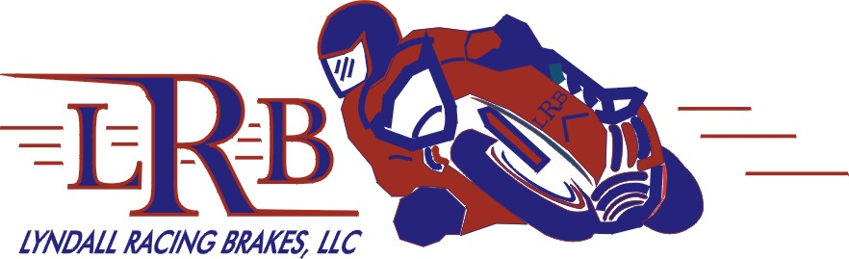

The best brake pad in North America returns
to Canadian racing for 2006 !

KMS Sportgroup Inc. and Lyndall Racing Pads LLC.
are proud to announce their continuing race contingency program
for the 2006 CMDRA Racing Season.

The Z-Pad, featured in this program is the premier street ridden
and track bred brake pad in it’s category in North America. In addition, the pure bred LRB Gold pad is also available for most of the popular race applications.

Applications include most V-twin stock calipers,
and virtually every performance caliper used on and off the race track!

Sign up now, and be a part of this exciting new CMDRA racing program.

For further information contact:

KMS SPORTGROUP Inc.
Tel (604) 298-5059 Tool Free: 1-866 -344 -5059 Fax (604) 298-8099 Toll Free Fax: 1-888 -298-8098
E-Mail: sales @kansport.com Web Site: www.kansport.com

“ Delivering the products of tomorrow, today ! ”

