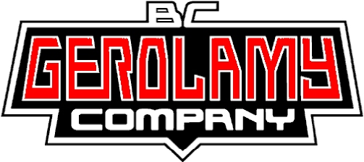 | Distributed By  KMS Sportgroup Inc. Tel: 604-298-5059  Fax: 604-298-8099  www.kansport.com  sales @ kansport.com

Dual Flow Daytona Twin Tec Package
with Over Flow Filter
The Ultimate EFI platform for Performance Applications
‘01-‘05 Delphi Replacement Throttle Body and Fuel Injection Controller for Twin Cam Engines
additional parts are needed for ‘06 and later applications

Package includes:
BC’s Dual Flow Throttle Body
- 50mm Tuned Port Dual Runner
- Increased Flow & port velocity
- Less Turbulence
- Uses stock injectors, MAP sensor AC, air temp sensor, throttle cables & cruise control
- Improves fuel distribution & eliminates charge robbing.
Dual Flow Throttle Body, backing plate & hardware kit, TCFI Plug-in Fuel Injection Controller, PC Link Interface Cable, Software, Wide-band Engine Gas Oxygen Sensor Interface, Wide-band Exhaust Gas Oxygen Sensor, (2)18 x 1.5 mm Weld Nut for exhaust pipe, plug and Over Flow Air Filter with hardware kit
Part # DF50-TTOF

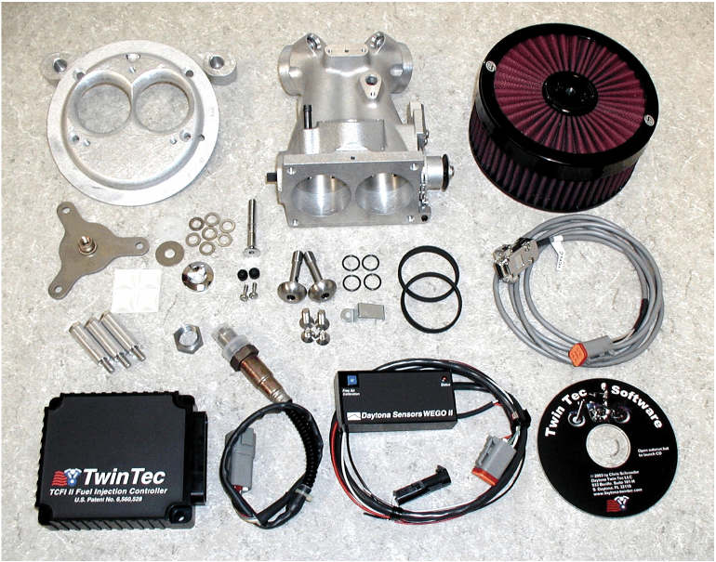 | Daytona Twin Tec TCFI Fuel Injection Controller  • Solves tuning problems with highly modified engines  • Auto-tune fuel curves with WEGO wide-band oxygen sensor  • Closed loop, highly accurate system monitors wide AFR range from 10.4 to 19.5  •Extensive data logging capability  BC’s Over Flow Air Filter  • Unrestricted air flow due to unique top filter design  •Low Profile  •Maximum air flow 800cfm  •US Made  •Washable / Reusable  • Works with most center-bolt hole style covers including most OEM Stock or Performance Models.

